(Approx. 1779 words)

Intro to Geocaching
Get outside, and find those hidden containers
By John Krout, Writer/Presenter, Potomac Area Technology and Computer Society
www.patacs.org
krout75 (at) yahoo.com

INTRODUCTION

What does geocaching mean? The word is derived from GEO, meaning the world, and CACHE, meaning a hidden container. The noun geocache means a box hidden somewhere, usually outdoors. The verb to geocache, or geocaching, refers to the process of the game. Another noun, geocacher, means anyone who plays the game.

The game got started in the general area of Portland Oregon in the year 2000. A hiker had several hiker friends and all owned hand-held GPS receivers. Those GPS receivers were the best solution of the time for tracking your hiking path, measuring the distance you traveled, and retracing your path back to your car.

The hiker decided to hide a box in the woods and obtained map coordinates of that spot using his GPS receiver. Then he emailed the map coordinates to his friends and challenged them to find the box. Many of them did and said they enjoyed the process thoroughly and asked him to do it again. Also, one or two of his friends hid other boxes and sent out map coordinates for those.

Eventually, a website was founded for providing the name, map coordinates, and other info about geocaches. The website URL is www.geocaching.com. Each cache has its own Web page on geocaching.com. As of early 2021, there are about 3 million geocaches in the world, and over 1 million inside the US.

When I learned of Geocaching, in November 2002, I had been a map collector for 23 years, and I owned a hand-held hiking GPS receiver. Since the GPS receiver was, at the time, the equipment needed to participate in geocaching, and since I have always been fascinated by maps and geographic information, in the spring of 2003 I decided to give it a try.

Fortunately, the price of game entry has declined a lot. Back in 2000, those hand-held GPS receivers cost upwards of $300. In mid-2002, My first one cost about $150. Today, you can use the GPS receiver built into your smartphone, and appropriate free apps, to see and save info on geocaches you want to find, to display the description and photos posted by finders, and to see a direction and distance to a geocache. You can also see a map of local streets and perhaps you can identify trailheads and nearby parking on the map.

There are urban and suburban geocaches also, where trails are not involved and sometimes you might be able to park within 10 feet or so of the hidden geocache. Near where I live, some of the Smithsonian buildings have geocaches on the grounds, placed by museum staff.

Each geocache contains, at a minimum, a paper log on which you sign your account name and the date on which you found the container. Bigger geocaches may also contain trade goods, sometimes called swag. If you want to remove a swag item, then the protocol is that you need to put something in its place, in trade. While growing up, my kids were very enthusiastic about inspecting all the trade goods in a cache, looking for something of interest.

One important constraint: never put candy or food in a geocache. Those things attract animals. If you find food or candy in a geocache, then remove it.

GEOCACHING.COM

The geocaching.com home page is shown in Illustration 1. You can tap the Play button, the triangle in the center of the home page, to see a 75-second video intro to the game.

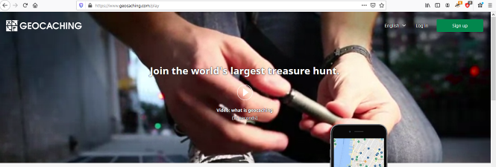Illustration 1
To obtain geocache info from this website, the site requires you to create a free account. Tap the SIGN UP button on the top right of the home page to begin creating your account. You need three items of info to create a free account: (1) an account name, 19 characters maximum, (2) a password, and (3) an email account. I strongly recommend that you do not use your first or last name in any one of those three items. The account name will be visible to all other account holders on geocaching.com, and the email account will be visible to system administrators. Keep it anonymous.
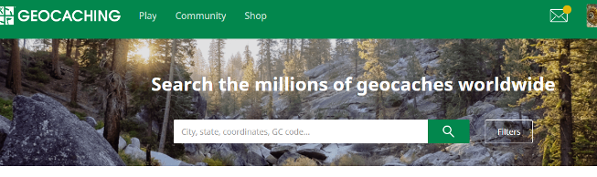Illustration 2
The basic use of geocaching.com is to identify nearby caches. After you create an account or sign in, you will use the Search field in the center of the page, as shown in Illustration 2. In the search field, type your home Zip code as a first search. That will produce a list of geocaches, in order by distance from the center of the Zip code. You can see an example in Illustration 3 for Zip code 22032.

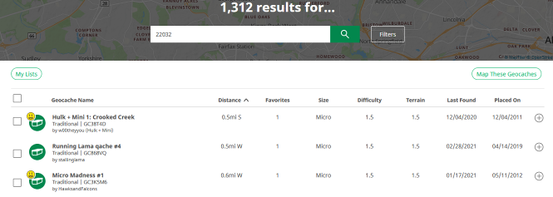Illustration 3
At the top right of the list, there is a Map these Geocaches button. Click that button, and geocaching.com will display a map. The map includes an icon for each geocache. The smiley icon tells me that I have already logged finding the cache, so I need not find that one again. You can see a sample map in Illustration 4. On the map, you can click on any geocache icon to read about it.  You can see the top of a sample geocaching.com page describing a cache in Illustration 5.  Geocaching.com does allow account holders to see map coordinates of geocaches, and to create an online log of their experience of finding each geocache. One advantage to you as an account holder for writing an online log is that geocaching.com reports to you the number of caches you have found. You can see some sample online logs from the sample cache page in Illustration 6. You will see an acronym TFTC in some of the logs. That is cacher-speak for Thanks for the Cache.  You can also report the condition of the geocache, and, in particular, if the paper log is full or is ruined by water. That will help the CO to maintain the geocache.  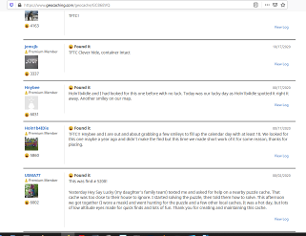Illustration 6  It can be fun in the online logs to provide hints indirectly that might help later cachers find the container.  GEOCACHING APPS FOR SMARTPHONES  I have used the c:geo app on my Android phone for about 7 years. It allows you to configure your account name and password so that the app can log into geocaching.com automatically whenever you start the app. | 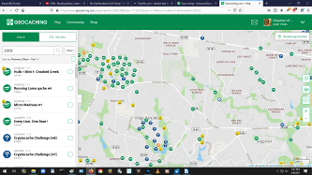Illustration 4  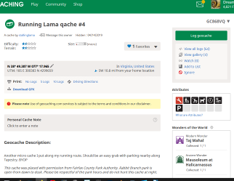Illustration 5
The app displays maps including cache icons, and you can tap a cache icon to read about it. You can save cache coordinates and other info on the smartphone for offline use, for instance in mountainous areas where cell power data service is unavailable. You can even install offline maps so that you can see the roads and trails without cell data service. You can use the app to log cache finds, though I prefer to write those logs on a computer.

Similar apps exist for iPhone and iPad users, such as Cachly and Looking4Cache.

WHO CREATES GEOCACHES?

Geocachers create geocaches. They want to give back to the geocaching community. They often want to show you a great spot that they have found, for instance, a waterfall known only to a few. Ruins and abandoned cars are popular hideouts. A person who creates a geocache, and writes about it on geocaching.com, is known as the Cache Owner, abbreviated CO.

The classic waterproof container is a US military metal ammunition box, known as an ammo box. Other typical containers are large plastic jars, like pretzel jars or nut jars. Smaller containers can include plastic sandwich containers, plastic military decontamination kits (decon kits), breath mint tins, pill bottles, and film bottles.

GEOCACHE SIZE RANGES

Knowing the size of a geocache often helps reduce the search effort. Every geocache has a size description, in addition to coordinates, terrain and difficulty ratings, and whatever else the CO wants to say about the cache. Here are the size definitions from the geocaching.com knowledge base, and some examples of containers:

LARGE= 20+ liters (sealed bucket)
REGULAR=1 liter to 20 liters (ammo boxes, plastic jars)
SMALL=100 milliliters to 1 liter (large bison tube or pill bottle)
MICRO < 100 milliliters (film bottle, pill bottle, small bison tube)

There is an informal type, called nano, a metal cylinder or plastic cone barely big enough to hold a 1/4th inch wide log strip wound into a spiral.

BENEFITS OF GEOCACHING

Aside from the bragging rights for finding lots of geocaches, for me, there have been health benefits. I was desk-bound as a software engineer and later a system documentation writer. In my case, I have gotten accustomed to hikes of 4 to 6 miles in up-and-down terrain, often an afternoon hike on trails to find half a dozen or more geocaches. My doctor told me to keep doing it, because the exercise brought down my blood pressure and heart rate, kept my weight down, and improved my stamina. I have hiked to find geocaches in parks and national forests in Virginia, where I live, but also In West Virginia, Wyoming, Texas, Massachusetts, Tennessee, Ohio, and many other states.

The parks generally welcome geocaches as a way to increase attendance in parks.

Urban and suburban geocaching is seldom so challenging physically, but the mental challenge is non-stop. There are indoor geocaches too, some in libraries, hidden between books or even inside a book.

GPS RECEPTION CAN VARY

GPS is not accurate even to the yard, and certain environments degrade the GPS signal. Trees do that, and tall buildings do that. Under trees, the accuracy is seldom better than about 20 feet, so when the GPS says you are close, look around and ask yourself: Where would I hide it?

In the woods, a common hiding tactic is to hide the container under sticks, bark or rocks, or in a hollow tree or log. Those man-made hideouts are called geopiles. You might also find an informal trail formed by prior finders, called a geotrail. I found one geocache a mile down a jeep trail in Idaho, under a pile of light-weight volcanic rocks, a type of rock I had never encountered on the East Coast.

A bigger GPS antenna helps. For most of us, the largest available antenna is in a tablet rather than a smartphone.

ABOUT THE AUTHOR: John Krout has been writing and speaking about creative uses of personal computers since the early 1980s. After a long career as a software engineer for federal contractors, he wrote technical documentation about a major federal computer system during his final 14 years on the job. He is now retired and lives in Arlington Virginia with his son, many computers and cameras, and too many cats.

